R&S Merge Cal

R&S Merge Cal allows the user to perform a single wideband calibration using a mixture of wideband and narrowband calibration standards.

# Terminology

In this document, the following terms are used with a specific meaning in the context of Merge Cal:

**Wideband:** Encompassing the entire frequency band of calibration

**Narrowband:** Encompassing a contiguous segment of the entire frequency band (wideband) of calibration.

# Cal Kit Requirements

To use Merge Cal, you must first construct appropriate cal kits. Each cal kit must contain the following standard:

* Wideband Short
* Two (2) Narrowband Offset Shorts
* Wideband Thru

These standards must either be of the correct connector type and gender, or be port-specific in such a way that they cover all ports to be calibrated.

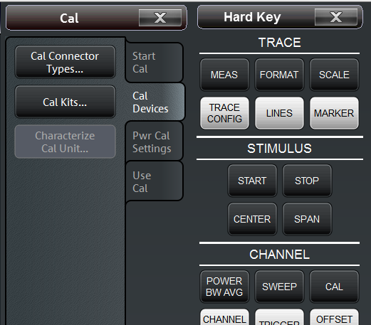Cal kits and connectors can be managed from the following menu:

Cal Connector Types and Cal Kits menus

Multiple cal kits can be used in a single cal. The narrowband offset shorts of each kit should altogether cover the wideband calibration range.

# Merge Cal Installation

To install R&S Merge Cal, copy the installer (.msi file) to the instrument, typically to the Windows desktop. Once copied, double-click the installer and follow the instructions.

The instrument may ask for an administrator password for installation. If you have not set one explicitly, it may be set at the factor with this default value: 894129.

# Use

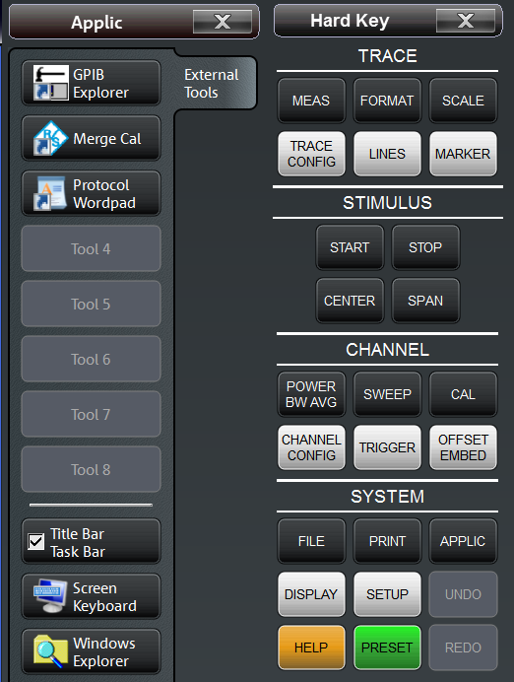The easiest way to start the application is from the External Tools menu on the instrument:

The application will start.

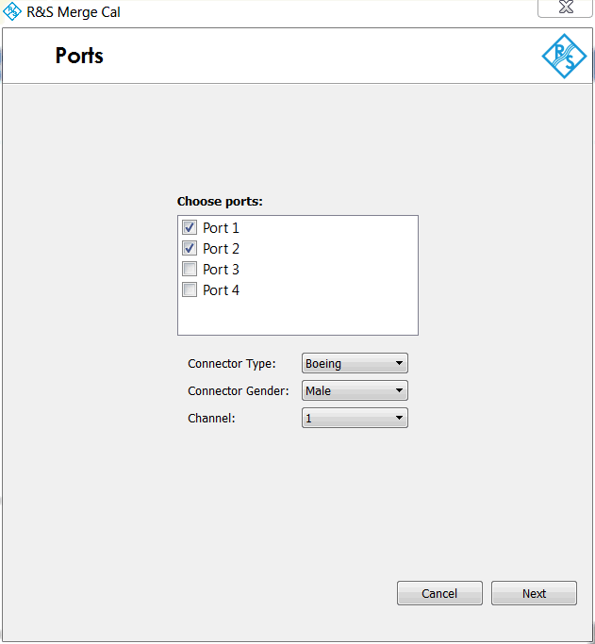Ports Screen

You should now see the Ports screen. From the list of available ports, choose which ports to calibrate. Also choose the connector type and gender of these ports. Note that all ports must be of the same connector type and gender. Also choose the channel to calibrate, then click “Next”.

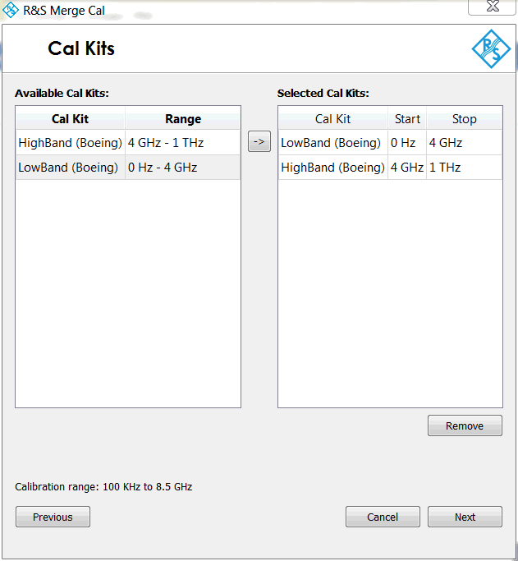

Cal Kits Screen

The Cal Kits screen shows a list of available cal kits on the right. These kits are based on the ports, connector type and gender on the previous screen. Also, only kits that meet the previously mentioned cal kit requirements are listed: wideband short, two narrowband offset shorts and a wideband thru.

From the list of available cal kits, choose the ones that you’d like to use for calibration. Cal kits are chosen by first selecting the relevant kit, then clicking the right arrow. The cal kit should show up in the “Selected Cal Kits” column on the right. Cal kits can be removed by highlighting it and clicking “Remove”.

For the selected cal kits, assign a narrowband frequency range for each to cover during calibration. The frequency range available corresponds to the narrowband range of the two offset shorts in that kit. The frequency range of the entire channel must be covered to proceed. For reference this range, labeled “Calibration range” is provided.

When finished, click “Next”

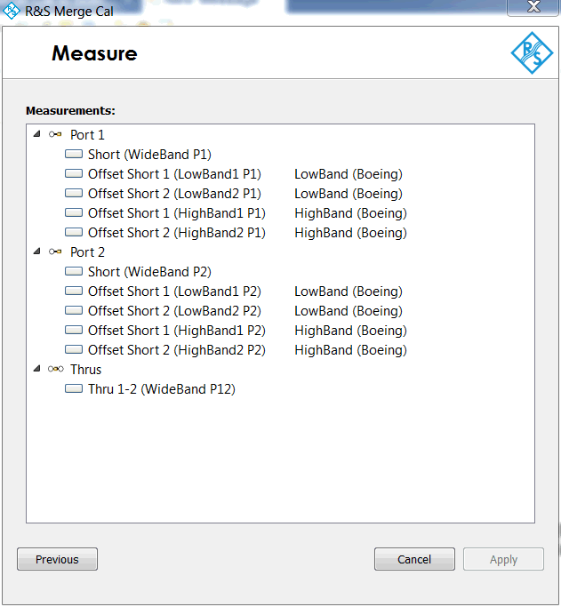

Measure Screen

The Measure screen leads the user through the physical calibration steps. Make the connections listed and click on each step to perform the corresponding calibration sweep. When all calibration sweeps have been performed, click “Apply” to apply the calibration results to the channel.